The training portion of the retreat
- Innovative instruction in a positive, fun setting  - New, unique curriculum for each retreat (page 10)  - Certified court and medical interpreters rave  about Interpreter Retreats (see page 3) | - Sight translation tips  - Optional local humanitarian project  - Simultaneous and consecutive interpretation techniques and activities
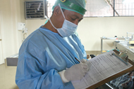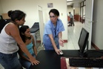
- DNA and lab test focus for each mode  - Develop a practical glossary  - Learn 6 techniques to incorporate terms in  your active vocabulary | - 20-hours of pre-approved credits  - No-interest monthly payment plan  - Registration and hotel comparable to national conference rates
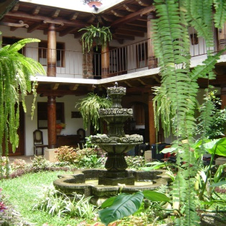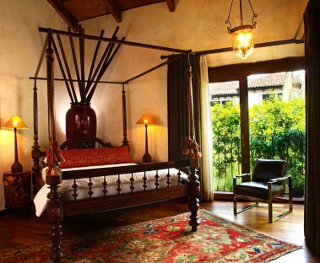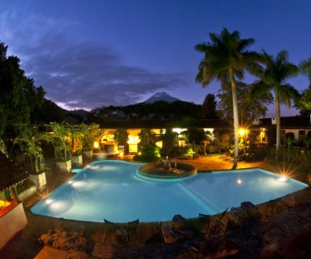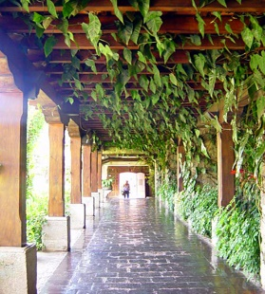
The resort portion of the retreat
- Immerse yourself in the history & culture of the former Convent of Santo Domingo and College of Santo Tomás de Aquino  - Now a luxury hotel and spa, voted #1 on TripAdvisor  - Modern guest rooms tastefully appointed with art and antiques | - Choose award-winning casual or fine dining  - Historical sites, shopping, and cultural activities within walking distance  - Outdoor adventures abound nearby
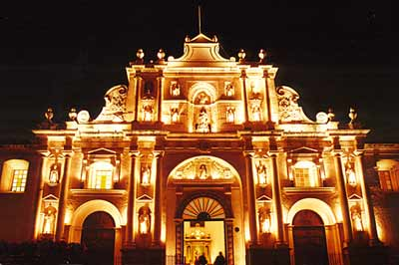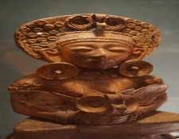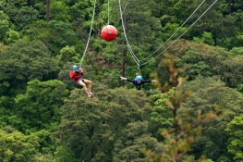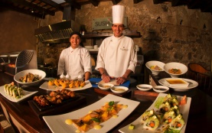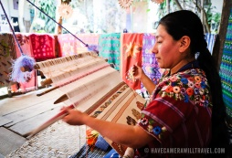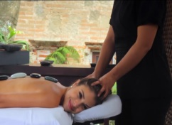

Our training philosophy:
- We guide you through self-assessment exercises that assist you in pinpointing your under-developed interpretation skills and in elaborating your own P₃ (Professional Progress Path).
- We cap enrollment at 15 to coach you in advancing toward attainable progress mile posts and tracking your development.
- We immerse you in high-energy activities that will increase and polish your interpretation skills.
- Due to the vibrant dynamics of our daily training sessions, we recognize that you will need to unwind and recharge. Retreat from the training room, and the world, to a hotel that caters to your recreational and relaxation needs so that you can return to the training room and the world of work refreshed and revitalized.
Whether you participate for continuing education or preparation for the next step in your interpretation career, in this course you will identify and refine your skills in a reassuring training atmosphere. Upon receiving your registration, we will solicit pre-approved CEUs from your state or association. Continuing education credit approval is pending California, Idaho, Oregon, Pennsylvania, Texas, and Washington State.
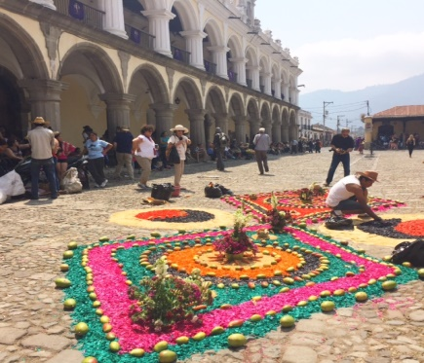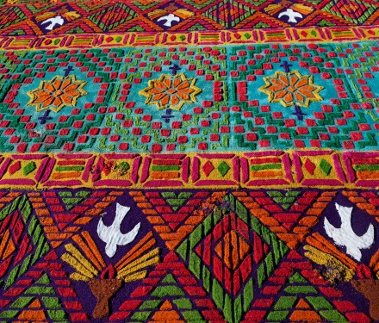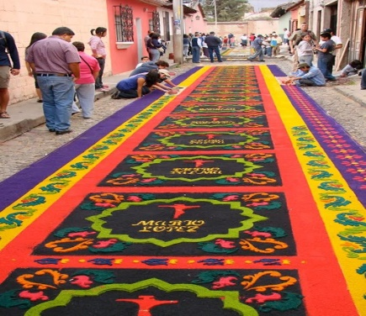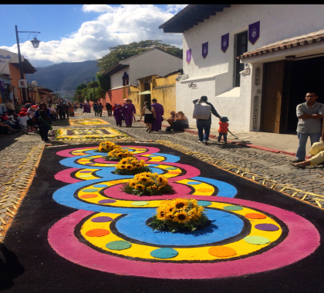
Trainer bio:
Christopher Dimmick has a passion for interpretation that is highly contagious in training sessions, which he has lead from coast to coast since 2002. He has trained over 4,500 interpreters who work in more than 40 languages. Chris holds a degree in Spanish Translation and Interpretation and has done graduate work and received instruction in small-group facilitation, learner-focused adult education, cross-cultural communication strategies, and experiential-based training of language professionals. As a Master-Level Certified Spanish Court Interpreter (Idaho, Oregon), Washington State Certified Spanish Court Interpreter, and a nationally Certified Medical Interpreter – Spanish (NBCMI), he employs unique instructional techniques targeting various learning styles and building upon each individual’s strengths.

What retreat alumni say:
“I liked the way the same topic (firearms) was woven seamlessly with the glossary for simultaneous and consecutive exercises. That provided great reinforcement and practice.” Federal and State Court Certified Interpreter

“This retreat was definitely at a higher level than most trainings. I was very pleasantly surprised at what I learned about automobiles.” State Court Certified Interpreter

“Your retreats are different than a classroom. I feel that they help me to keep a balance and refocus my life and work as an interpreter.” State Court Certified Interpreter

“I loved the structure. I felt that I could relax because someone else was in control and kept the talkers in line.” Federal and Court Certified Interpreter

“Physiology of interpretation, well-organized and useful exercises, the vocabulary development was very good.” State Court Certified Interpreter

“The positive karma, the perfect mix of hard work, laughter and activities.” State Court Certified Interpreter

“I loved it! This is the best workshop/retreat that I’ve taken. I loved the focus on car terminology. I also liked that the group had similar experience/training/level. The kick-off party was a fun way to break the ice.” Federal and Court Certified Interpreter

“I learned a lot about firearms. I loved Cartagena. My goals were reviewed and improved. The payment plan was perfect for me.” State Court Certified Interpreter

La Antigua – also named a UNESCO World Heritage Site - is a charming city in the high plains of Guatemala, about 45 minutes from the capital. The city is probably best known for three things: the beautiful Spanish-style architecture and cobblestone streets built in the 16th century (preserved by law to this day), the many ruined churches and monasteries, casualties of the 1773 earthquake, and the majestic volcanoes looming on all sides. It is popular among tourists at all times of the year and is teeming with great restaurants, Spanish-style hotels with flowered courtyards and dozens of Spanish-language schools.

One of the world’s great historical and cultural treasures, Guatemala was declared World Heritage site by UNESCO. Sacatepéquez is one of Guatemala’s more fascinating districts, known not just for its peculiar geographical location but also for its extraordinary cultural heritage. The town’s psychic legends include stories of ghosts and souls in pain such as “el sombrerón, la llorona, los rezadores, el cadejo, el cura sin cabeza.”

La Antigua has preserved its colonial charm over the years and offers a perfect climate that makes it the prime destination for tourists. Visitors can enjoy shopping at any of the many markets located within the city as well as visit the ruins of the old convents.
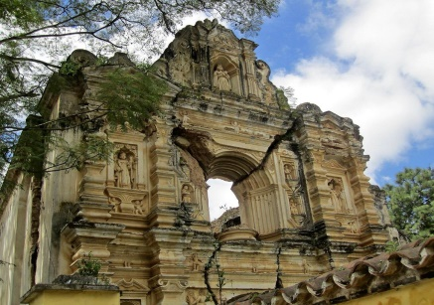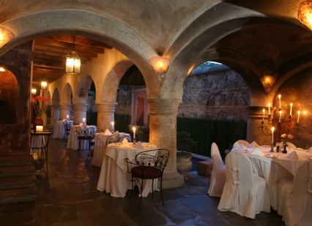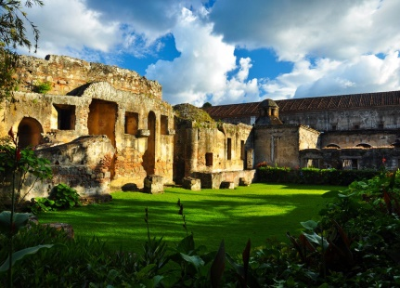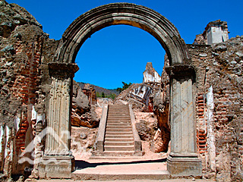Once you step through our doors prepare to be whisked away to another time and place. Our innovative La Antigua hotel offers 130 beautifully appointed guest rooms. The décor includes works of art from renowned Guatemalan fine artists and handmade textiles with traditional-contemporary designs. Modern comforts include LCD televisions with cable, telephones with voicemail, minibars, safety deposit boxes, irons and ironing boards, hair dryers, magnification lighted vanity mirrors, hypo-allergenic pillows (on request), bathrobes, twice-daily housekeeping service, fireplaces, high-speed Internet, terrace, balcony, tub, and Jacuzzi or sauna (in selected rooms). Virtual tour of the resort: http://www.casasantodomingo.com.gt/photo-en.html
During your stay at Casa Santo Domingo enjoy a wealth of on-site services and accommodations. Relax in our sauna or Jacuzzis, exercise in the gym or enjoy a pleasant swim in our swimming pool. Free yourself from stress and treat yourself to a relaxing massage. Tour our kitchen, where you will be able to select the dish of your preference and have it prepared according to your taste. Enjoy your favorite drink in our elegant Sushi-Bar or visit the Museum Promenade to explore Guatemalan art, culture and history.

Why choose this Winter Retreat? Just compare:
Training event for CEUs | Cost per training hour, including hotel and airfare | Total training hours | Hands-on professional development with feedback | Paradise
Caribbean Retreat for Court Interpreters of All Languages | $103.00 per training hour | 20 hours | Yes | Yes, see page 5!
National conference | $104.00 per training hour | 15 hours | No | N/A
National conference | $105.00 per training hour | 20 hours | No | N/A
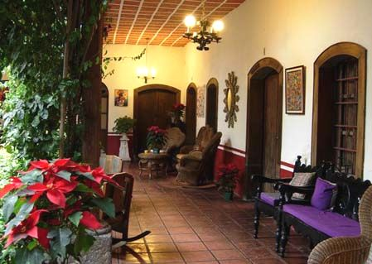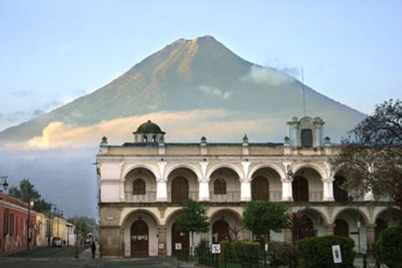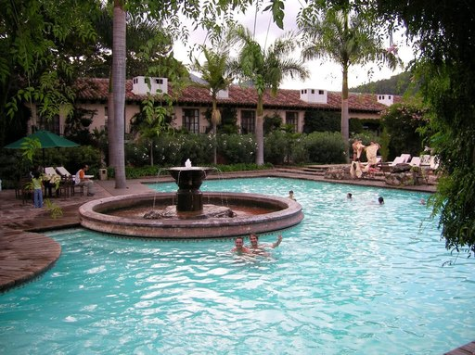

Winter Retreat training/hotel registration
Per person early registration received by July 31, 2017 (Subject to availability) | $1750 total
Per person registration received by September 30, 2017 (Subject to availability) | $2000 total
Per person registration received after October 1, 2017 (Subject to availability) | $2250 total
(Included: Training and materials, six-night stay in an Estancia Tradicional/Traditional Room,single or double occupancy, kick-off cocktail party, lodging taxes) Check-in March 11, Check-out March 17
(Not included: Airfare -as low as $350 round trip, $50 airport transportation, food and beverage)
ESTANCIA TRADICIONAL DE LUJO (single or double occupancy)  All with two full-size beds, bathroom, flat screen T.V., minibar, fireplace, telephone, living room, terrace or balcony | $45 per night upgrade
ESTANCIA EJECUTIVA (single or double occupancy)  Bedroom with one king-size bed, bathroom, flat screen T.V., minibar, fireplace, telephone and living room. | $51 per night upgrade
ESTANCIA CONVENTUAL (single or double occupancy)  Bedroom with one king-size or two full-size beds, bathroom, flat screen T.V., mini–bar, fireplace and telephone. In a separate ambient a living–dining room. Most rooms have a terrace or a balcony. | $86 per night upgrade
ESTANCIA CONVENTUAL DE LUJO (single or double occupancy)  Bedroom with one-king size or two full-size beds, bathroom, flat screen T.V., minibar, fireplace and telephone. In a separate ambient a living – dining room. Most rooms have a terrace or a balcony. | $116 per night upgrade
ESTANCIA MASTER (single or double occupancy)  Bedroom with one king-size bed, bathroom, Jacuzzi, flat screen T.V., DVD player, minibar, fireplace, telephone,  living–dining room and terrace. | $236 per night upgrade
Retreat participants wishing to share a room with a fellow participant should register at the same time as the roommate and list the roommate on the registration form on page 8. Each participant will receive a $300 discount off their registration fee.
Group rate honored two days before/after Winter Retreat!
Payment plan: We’ll bill your credit/debit card in equal payments on the 15th of each month (through February) so that you can plan for the Winter Retreat with peace of mind.

Receive a $50 rebate off your Winter Retreat registration when you refer another interpreter who applies for this Winter Retreat or the Caribbean Retreat in St. Thomas, US Virgin Islands is accepted.

Winter Retreat Application – Part 1
Please type responses below and email as an attachment to projects@MDtranslation.com
Type “Caribbean Retreat Application” in the email subject line.
Retreat applicant name
Mailing address
Email address
Phone number
Language background
What languages do you speak?
How did you acquire your first language skills?

How did you acquire your second language skills?

What is your educational background? (K-12, undergraduate, graduate, when, where)

Interpretation background
What is your interpretation background? (certification, experience, fields, yearly continuing education)

In which states are you court certified?

What percentage of your week is spent interpreting in court or in a legal setting?

What interpretation skills do you feel are your strongest?

What interpretation skills would you like to refine more?

(Continued on Page 8)

Winter Retreat Registration - Part 2
Check one:
 | Per person early registration received by July 31, 2017 (Subject to availability) |  |  |  |  |  |  |  |  |  |  |  |  |  |  |  |  |  |  |  |  |  |  |  |  |  |  | $1750
 | Per person registration received by September 30, 2017 (Subject to availability) |  |  |  |  |  |  |  |  |  |  |  |  |  |  |  |  |  |  |  |  |  |  |  |  |  |  | $2000
 | Per person registration received after October 1, 2017 (Subject to availability) |  |  |  |  |  |  |  |  |  |  |  |  |  |  |  |  |  |  |  |  |  |  |  |  |  |  | $2250
Receive a $50 rebate off your Winter Retreat registration when you refer another interpreter who applies and is accepted for this Winter Retreat or the Caribbean Retreat in St. Thomas, US Virgin Islands. Type the name of your referral:
Upgrades & Additions (Subject to availability) Casa Santo Domingo Resort

ESTANCIA TRADICIONAL DE LUJO (single or double occupancy) upgrade
Mark  dates |  |  | 9th |  | 10th |  | 11th |  |  | 12th |  | 13th |  | 14th |  |  | 15th |  |  | 16th |  | 17th |  | 18th |  | Upgrade amount |  | Total
 |  |  |  |  |  |  |  |  |  |  |  |  |  |  |  |  |  |  |  |  |  |  |  |  |  | @ $45/night |  | $

ESTANCIA EJECUTIVA (single or double occupancy) upgrade
Mark  dates |  |  | 9th |  | 10th |  | 11th |  |  | 12th |  | 13th |  | 14th |  |  | 15th |  |  | 16th |  | 17th |  | 18th |  | Upgrade amount |  | Total
 |  |  |  |  |  |  |  |  |  |  |  |  |  |  |  |  |  |  |  |  |  |  |  |  |  | @ $51/night |  | $
ESTANCIA CONVENTUAL (single or double occupancy) upgrade
Mark  dates |  |  | 9th |  | 10th |  | 11th |  |  | 12th |  | 13th |  | 14th |  |  | 15th |  |  | 16th |  | 17th |  | 18th |  | Upgrade amount |  | Total
 |  |  |  |  |  |  |  |  |  |  |  |  |  |  |  |  |  |  |  |  |  |  |  |  |  | @ $86/night |  | $
ESTANCIA CONVENTUAL DE LUJO (single or double occupancy) upgrade
Mark  dates |  |  |  | 9th |  | 10th |  | 11th |  |  | 12th |  | 13th |  | 14th |  |  | 15th |  |  | 16th |  | 17th |  | 18th |  | Upgrade amount | Total
 |  |  |  |  |  |  |  |  |  |  |  |  |  |  |  |  |  |  |  |  |  |  |  |  |  |  | @ $116/night | $
ESTANCIA MASTER (single or double occupancy) upgrade
Mark  dates |  | 9th |  |  |  | 10th |  | 11th | 12th |  |  |  | 13th |  | 14th |  |  | 15th |  |  | 16th |  | 17th |  | 18th |  | Upgrade amount | Total
 |  |  |  |  |  |  |  |  |  |  |  |  |  |  |  |  |  |  |  |  |  |  |  |  |  |  | @ $236/night | $
ADDITIONAL NIGHTS ESTANCIA tradicional (single or double occupancy) PLUS upgrades above
Mark  dates |  | 9th |  |  |  | 10th |  | 11th | 12th |  |  |  | 13th |  | 14th |  |  | 15th |  |  | 16th |  | 17th |  | 18th |  | Additional nights | Total
 |  |  |  |  |  |  |  | Included in training registration |  |  |  |  |  |  |  |  |  |  |  |  |  |  |  |  |  |  | @ $151/night | $

ADDITIONAL third guest in room over 11 years old (maximum three guests per room)
Mark  dates |  |  | 9th |  | 10th |  | 11th |  |  | 12th |  | 13th |  | 14th |  |  | 15th |  |  | 16th |  | 17th |  | 18th |  | Upgrade amount |  | Total
 |  |  |  |  |  |  |  |  |  |  |  |  |  |  |  |  |  |  |  |  |  |  |  |  |  | @ $45/night |  | $
If sharing a room with non-Retreat guest(s), type their name(s):
If sharing a room with another Winter Retreat participant, type their name: |  |  |  |  |  |  |  |  |  |  |  |  |  |  |  |  |  |  |  |  |  |  |  |  |  |  |  | $300 credit
Please detail any food allergy or dietary restriction:

(Continued on page 9)

Winter Retreat Registration - Part 3
Payment information
Registration | $ | Upgrades | $ |  |  | Additions |  | $ | Credit |  | $ |  |  | Grand total |  | $
Payment Plan: Yes, I want equal payments withdrawn the 15th of each month (thru Feb.)
Card #: |  |  |  | Credit: |  |  | Debit: | Visa: |  | MasterCard: |  |  | Discover: |  |  | American Express:
Card holder name:
Card billing address:
If you would like to give us your payment information via telephone, dial (208) 365-2622. Please leave a voice mail if we are out of the office.
By typing my name below, I fully understand that should this Caribbean Retreat application be accepted,
the above-mentioned card shall be automatically charged the non-refundable grand total listed above
plus a 3% credit card processing fee.
Card holder electronic signature |  |  |  |  |  |  |  |  |  |  |  | Date
Should Winter Retreat enrollment be full when registration is received, no charges will be made to your credit card.

Draft Agenda
March 12  8:00-1:00 | March 13  9:00-1:00 | March 14  9:00-1:00 | March 15  9:00-1:00 | March 16  9:00-1:00
The physiology of interpretation part 1: warming up for interpretation – 1 hr | The physiology of interpretation part 2: warming up for interpretation – 1 hr | Laboratory visit and forum with lab techicians - 2 hrs | The physiology of interpretation part 3: warming up for interpretation – 1 hr | Ethics exercise -1 hr
Tri-modal skills orientation - ½ hr | Glossary development: Discussion of DNA terms from Day 1- 1 hr | Discussion of terms from laboratory visit – 1 hr | Tips for sight translation – 1 ¾ hrs | Cultural considerations in interpretation ¾ hr
Consecutive exercise: DNA expert – 1 hr | Coffee break – ¼ hr | Ethics exercise –1 hr | Coffee break – ¼ hr | Simultaneous interpreation tips – ¾
Coffee break – ¼ hr | Professional Progress Plan (P₃) to refine simultaneous and consecutive interpretation skills – 1 hr | Lunch on your own in the city | Consecutive interpretation techniques – 1 hr | Coffee break – ¼ hr
Simultaneous exercise : DNA expert – 1 hr | P₃ instructor coaching  and peer review - ¾ hr | 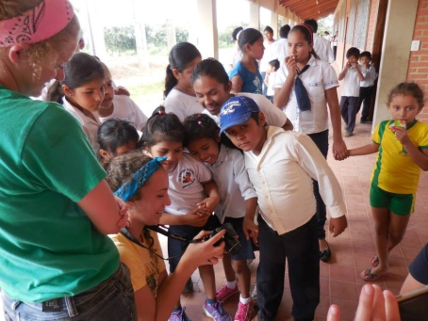  Optional local humanitarian activity |  | Professional Progress Plan (P₃) to refine simultaneous and consecutive interpretation skills – ½ hr
Identifying and prioritizing  underdeveloped interpretation skills – 1 hr |  |  |  | Professional Progress Plan (P₃) trimodal interpretation skill refinement application beyond St. Thomas – ¾ hr
Mile-markers for
interpretation skills – ¾ hr
6:00 Winter Retreat kick-off party

